1. Run generator.py file

Give datapath of the directory where you want to store the logs of 1000 servers.

Example command: python generator.py C:\Users\pranj\OneDrive\Documents\cdnetworkslogs

1. Run query.py file

Give datapath of the directory where the logs of 1000 servers are stored.

1. Input query

Example: QUERY 192.168.0.1 1 2014-10-31 00:00 2014-10-31 00:05

Example: EXIT

Output Example:

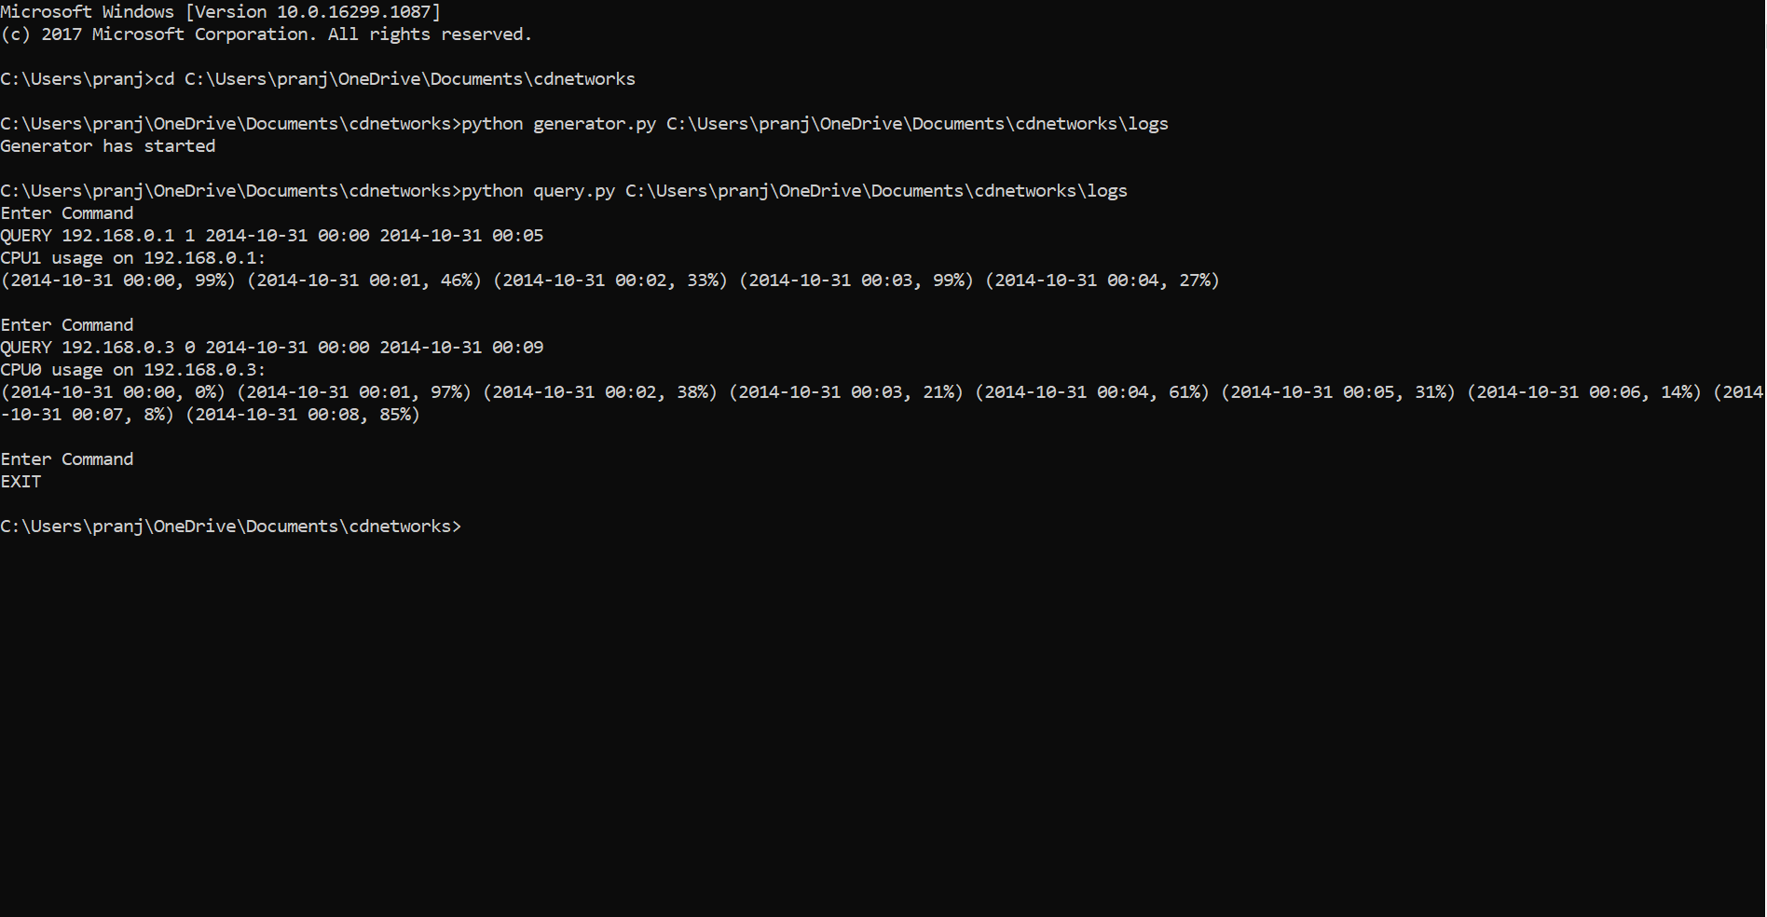

Note: If running on Linux OS

Enter commands : chmod 755 generator.py

chmod 755 query.py

./generator.py <Datapath>

./query.py <Datapath>